DAY-1

**Name:** N Sai Pranadeep Reddy

**Rg no:** 192110129

**Course name:** Software engineering

**Course code:** CSA1001

**Faculty name:** DR.G.Mary Valantina

**Date:** 26-09-2022

**Experiment.no-1 : online voting**

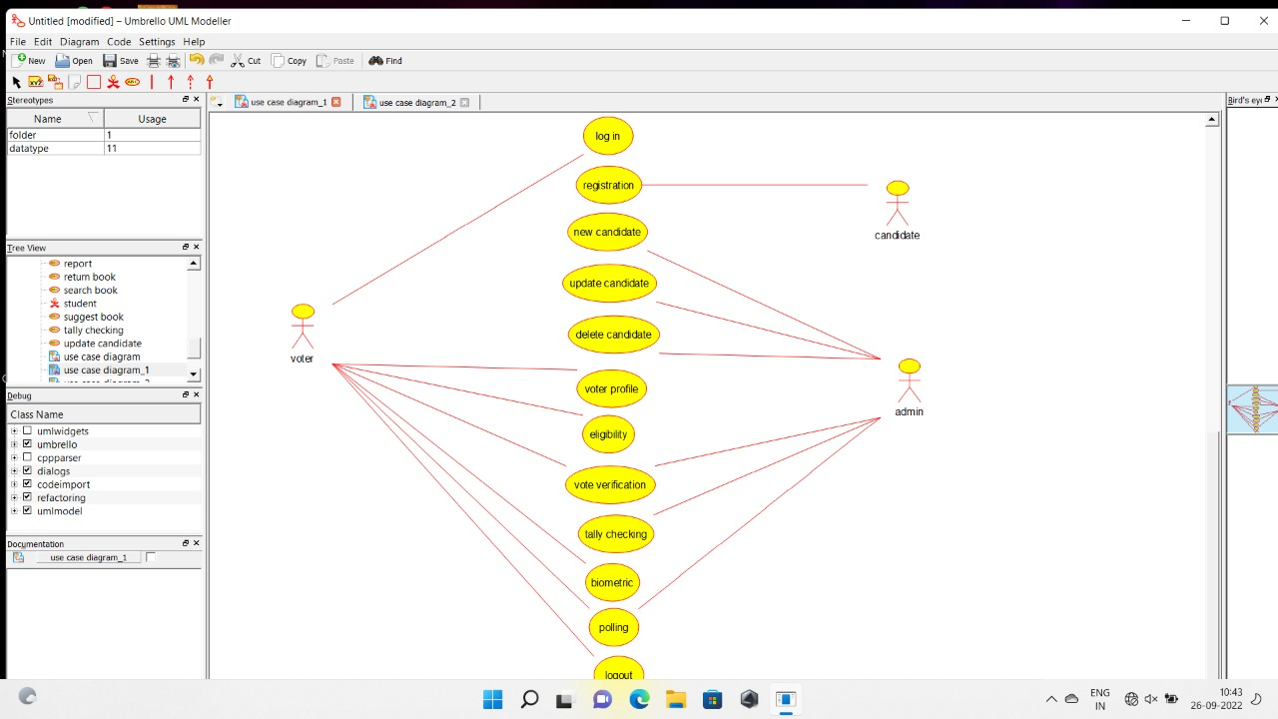

**Experiment.no2: Library management**

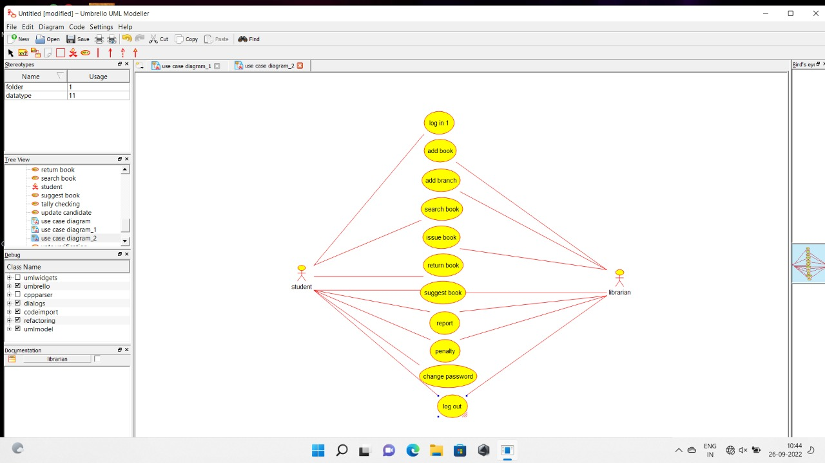

**Experiment.no3: compute the quotient and remainder**

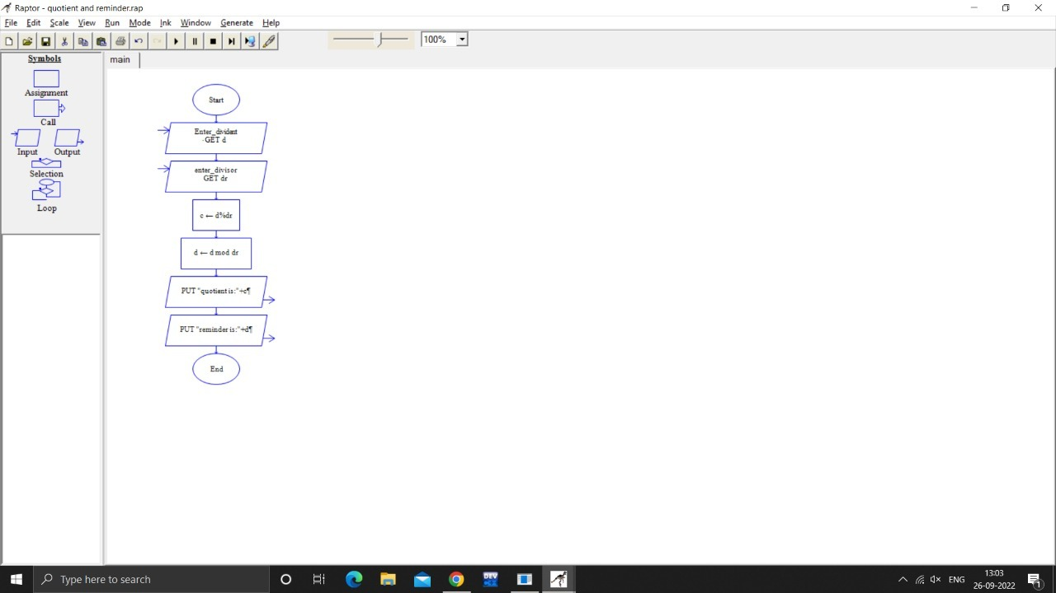

**Experiment.no4: Online shopping**

